Design and Analysis of Fuel Cell Vehicle-to-Grid System

* P. Navya Surya Praveena and P. Uday Ashish

***Abstract*— The primary goal of the study is a part of the integration of Fuel Cell Vehicles (FCVs) with Vehicle-to-Grid (V2G) technology, thus showing the potential for the energy of the vehicle to contribute toward the electrical grid. This study primarily focuses on the system to integrate low-voltage energy from FCVs to the higher-voltage grid. This is why a single-switch DC-DC converter conducts the boosting of the voltage for using the fuel cell in conjunction with the mains grid, while at the same time the energy transfer process is very smooth, achieving an optimized power output. The system allows for 10 kW fuel cell which can feed both homes and feed back into the electrical mains at 220V/50 Hz. In any case where the demand back home is low, all the surplus power goes to the grid, and the difference may be supplemented whenever the demand peaks high than what the FCV could feed to it.**

1. Introduction

Renewable or clean energy is that which is derived from natural sources replenished naturally. Examples of such sources include sunlight, wind, rain, tidal forces, and geothermal heat. Renewable energy has a cleaner source compared to fossil fuel, which is consumable and degrades the environment due to carbon emissions and pollution. These elements are harnessed by conversion to electricity through solar panels, wind turbines, and hydropower plants, thus reducing our reliance on coal, oil, and natural gas. Renewable energy also allows a fight against global warming, cutting through the removal of harmful emissions of greenhouse gases as well as promoting sustainable development. Such transitions towards renewable sources of energy will also foster a strong, sustainable, and energy-secure future that propels the economy to new heights in perpetuating growth and innovation about green technologies [1,2,3].

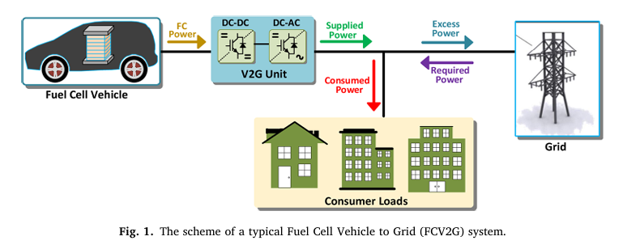

Fig 1: Typical FCV2G System

But new technologies continue to come in the form of high efficiency photovoltaic cells and high voltage-gain converters, which allow renewable sources of energy to be always accessible and economical for everyone.

This technology V2G is very suitable for fuel cells because it produces continual reliable power under variable load conditions with high efficiency [4]. Although EVs are acting as an energy storage source in a V2G system and supply electricity back to the grid, Fuel cells are ahead of fuel cells in most aspects. In a fuel cell, electrical energy is produced in a chemical reaction from which the only product of this process is water. Fuel cells, therefore, can be described as clean-burning, high-conversion efficiency power generators and potentially ideal for grid stabilization and other forms of power during peak-demand time. Whereas for PV cells, one requires sun's energy, thereby dependent on conditions of weather and daylight hours, fuel cells can operate continuously hence the supply of power is not limited by environmental conditions. Steady output is highly significant for V2G purposes because it would give automobiles the potential to be able to always provide power once it is needed and not just during sunny days. Although the low running costs and renewability place a great demand for PV cells[19], it places some limitations for its usages in V2G applications. For instance, since the nature of solar power is intermittent, the PV cells cannot guarantee any level of consistency of energy flow to the grid when it would be less on certain nights or on cloudy days, which thus causes reliability problems[5],Another is that solar panels typically take up much space in installations and may degrade with time, hence bringing down the efficiency level.

Electric vehicles spend most of their time idling and are thus valuable sources of supplementary power [6,7]. There are many forms of EVs. There is, of course, battery electric, plug-in hybrid, and even fuel cell, with each having some unique advantage that places it in a better position for integration into the grid. BEVs have a relatively short life cycle because of its battery capacity, and recharging times are relatively long, apart from having relatively difficult recyclability issues because of the environmental concerns. FCVs shall also be assisted by hydrogen for producing electricity and making refuelling faster, covering much greater distances, and it produces water as an exhaust, thus making it environmentally friendly. Studies have shown that FCVs are very useful, especially if interfaced to the grid at challenging times, whereby they might perform better than BEVs. FCVs support clean air and low greenhouse gas emissions, although the environment produced will depend on the source of hydrogen fuel that is produced, which is not always carbon-free at the time [8].

2. Vehicle to grid System

The technology of FCV2G enables support for renewables as it acts like a distributed generation in the grid. Hence, the power network linkage of FCVs will be able to ensure saving of energy while improving the management of local energy. Thus, by careful designing of power electronics and controls, effective transfer of energy can be ensured towards the attainment of this V2G technology. [15]

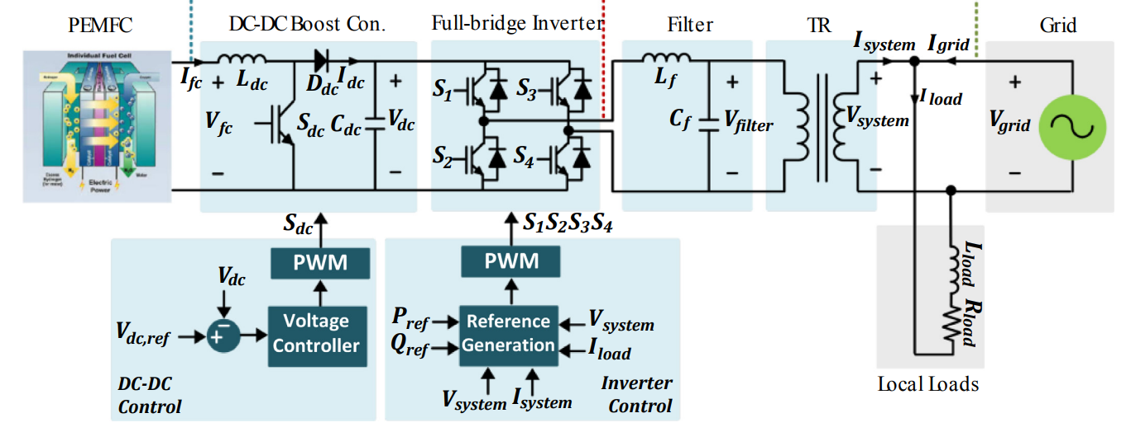

Fig .2 Typical Circuit Diagram of V2G Model

3. Fuel Cell Model

In this section, MATLAB Simulink Implementation of FC Model is discussed:

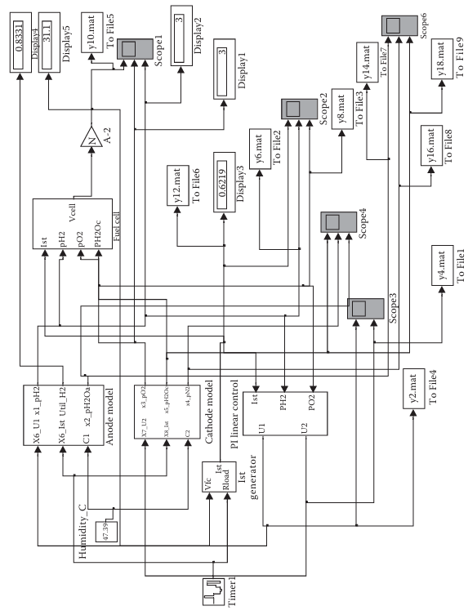

Fig .3 Fuel Cell Model

Fuel cell model consists of anode model, cathode model, fuel cell voltage model, and control block. The output voltage of fuel cell stack voltage is as follows [1,12]:

(1)

Vnerst is the reversible output voltage potential. Vcon is the Concentration Voltage, Vact is the Voltage of activation voltage and Vohmic is the voltages of ohmic losses. The Nernst voltage is obtained as follows:

(2)

(3)

(4)

(5)

where, ​ represents the standard reference voltage, which is given as 1.229 V [9]. denotes the temperature of the fuel cell (in Kelvin). ​ and ​ refer to the partial pressures (in Pascals) of hydrogen and oxygen gases, respectively. and indicate the cell current and the maximum current of the PEM fuel cell. The empirical coefficients for each cell are represented by ​ ​. ​ and ​ denote the membrane and contact resistances, respectively.

The explanation of each voltage and other voltages are given in [10,11].

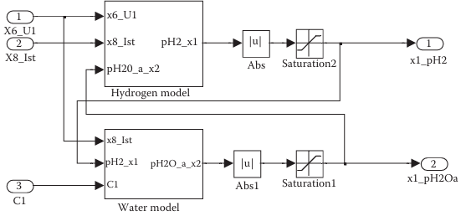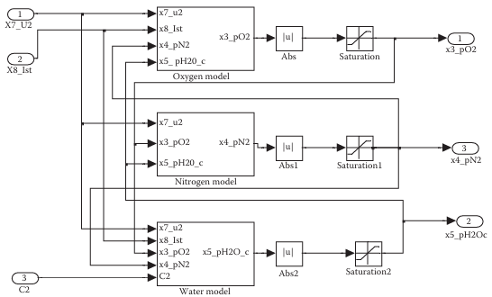

Fig .4 (a) Anode Model and (b) Cathode Model

The Anode Model consists of Hydrogen Model and Water model as shown in fig.4(a). The Cathode block consists of Oxygen block, Nitrogen Block and Water Block as shown in fig.4(b).

The splitting leads into anodic and cathodic models, which in turn results in a higher resolution of the details of simulation results, thus to a better knowledge of operation regarding fuel cells and also supports a more effective control and optimization strategy.[18,14]

The stack current is generated by the fuel cell voltage, and the load block, an timer [0, 15, 20, 25, 30, 35, 40, 45, 50, 55] with resistor values [1, 0.6, 0.3, 0.175, 0.3, 1, 2.5, 5, 1, 5] Ohms.

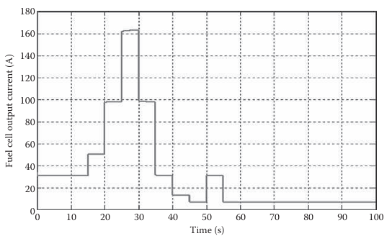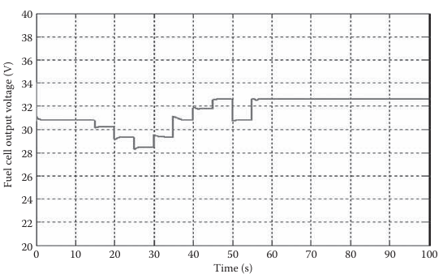

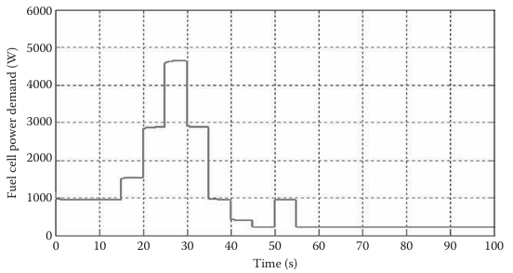

Fig .5 Profile of Fuel Cell (a) Current (b) Voltage (c) Power under different load variations

From the above graphs of Current, Voltage, Power with time it is noted that at 28 sec the current is high, and the voltage is low, but the power is high. From this, The power is Directly proportional to Current and Inversely Proportional to Voltage Under different Loads.[8,21]

Fuel Cell Parameters

|  |  |  |  |  |
| --- | --- | --- | --- | --- |
| **Parameters** | **Value** |  | **Parameters** | **Value** |
| Anode volume, | 6.495 |  | Mole fraction of H2, | 0.99 |
| Cathode volume, | 12.96 |  | Mole fraction of O2, | 0.21 |
| Fuel Cell active area, | 232.0 |  | Mole fraction of N2, | 0.79 |
|  | 1.2684 |  |  | 4 |
| Power output, | 101325 |  | Constants in mass transfer Voltage. m | 2.11 |
| cell number, N | 35 |  | n | 0.008 |
| Universal Gas Constant, R | 8.314 |  | K |  |
| Temperature, T | 338.5 |  |  | 0.1 |
| sample time, | 2 |  |  |  |
| Faraday Constant, F | 96485 |  |  |  |
| Hydrogen (H2) Gas inlet in mole/sec, | 7.034 |  |  | N* |
| Oxygen (O2) Gas inlet in mole/sec, | 7.036 |  |  | 1.2584*N*/F |
| Anode Conversion Factor, | 0.065 |  | Cathode Conversion Factor, |  |

4. DC-DC Boost Converter

The Vehicle-to-Grid (V2G) interface operates using power electronics-based converters like DC-DC Boost Converter. An efficient transfer of power from fuel cells to the electric grid requires a DC/DC boost converter, as the fuel cells generate only a variable, relatively low DC voltage, and this will vary with changes in load, temperature, and pressure and, therefore, requires a boost converter to increase this voltage to a stable level that could be connected directly to the grid[16]. This is then boosted by the DC/DC boost converter to match the voltage required by the DC/AC inverter, which subsequently generates an AC voltage feed to the grid. This regulation is necessary because electric grids demand well-constant input voltages for efficient and reliable power delivery. Without the boost converter, there would be the inefficiency of fluctuations in the fuel cell voltage that causes low-quality power and possible instability in the grid supply. [17,20]

|  |  |  |
| --- | --- | --- |
| Circuit | Gain | Parameters |
|  |  | Inductance, L=1  Capacitance, C=1  Switching Frequency=5Khz |

**Boost Converter**

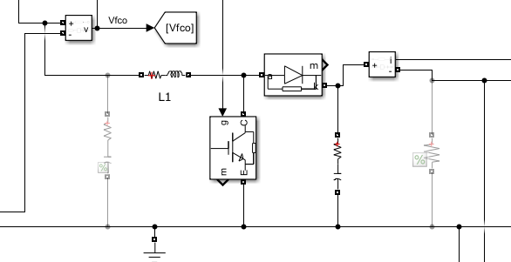

Fig .6 Boost Converter Circuit Diagram

5. PI Control Strategy

In this technology of V2G, the PI control strategy is a critical power-flow management system between the power source of a vehicle in this case a fuel cell or battery and the electric power grid. The reason for using a PI strategy in a V2G system is based mainly on considerations of simplicity and also because of the high dependability of maintaining stable transfer of power. It works by generating error feedback from the difference between the desired and actual values of Voltage and feeds it into control signals. The error, therefore, has two parts: a proportional term that reacts with immediate changes and an integral term meant to aggregate past errors, especially geared to correcting steady-state deviations[9]. Collectively, these two properties make possible the capability of tracking of reference voltage inputs with high response speed and good long-time accuracy - the precursory requirements for stabilizing power flow and grid voltage in V2G applications. The PI control strategy plays a dominant role mainly in regulating the output of the DC/DC converter and the DC/AC inverter in the V2G system. As an illustration, the PI controller can ensure that the voltage coming from the fuel cell feeding a DC/DC converter has a stable output and is produced by modulated duty cycle of the converter. This is important since fuel cells and batteries exhibit non-linear characteristics in terms of voltage, load, temperature, and state of charge. With this adjustment, the system can adapt to the same with a PI controller.

Parameters:

Gain K: 0.007.

Proportional Constant Kp: 0.6.

Integral Constant Ki: 8.

Fig .7 PI Controller Circuit Design

Fig 8.1 of Boost Converter



Fig 8.2 of Boost Converter

Fig 8.3 at fuel cell A black rectangular object with a yellow line

Description automatically generated

Fig 8.4 Duty Cycle

Boost Converter attained an efficiency of 93.75% at 0.76 duty cycle at equilibrium condition.

6. DC-AC Converter and Control

Actually, DC/AC inverter is considered to be the core part in V2G technology; DC side is where fuel cells produce a DC voltage and power received from it feeds into the AC grid, which normally supplies an alternating current (AC). Once the stable DC output voltage is developed by the DC/DC converter of the fuel cell, then DC/AC inverter has to carry out the conversion from the stable DC voltage to a suitable AC grid-compatible voltage. This conversion is quite important in that the power produced by a fuel cell is basically for consumption by an electric grid, which operates on standard AC frequencies, normally 50 or 60 Hz. The inverter does not have the purpose of conversion alone but also ensures that the AC output comes with synchronization in phase and frequency with the grid, which is a requirement for the safe and stable integration of the V2G system.[13]

To meet this end, several control techniques comprising of PWM or SPWM generate a smooth AC waveform that satisfies the conditions of grid voltage and frequency. Further, an inverter may also be additionally provided with a filtering stage that, in most cases, is an inductive L filter which causes the high frequency switching ripples produced during DC to AC inversion to be minimum. These ripples, if not filtered, can also cause noise or instability in the power being supplied to the grid. Proper management of these technical requirements by the inverter ensures smooth and efficient power flow to the grid from the fuel cell, thereby enhancing the reliability of the V2G system. V2G technology can contribute to grid stability by playing a role for the DC/AC inverter, providing clean energy from the renewable sources, balancing demand, and allowing for highly efficient bi-directional energy flow.

Fig 9 DC/AC Converter Circuit Diagram

Parameters:

Filter Inductance L: 1H.

Filter Capacitance C: 1 F.

Fig 10.1 Grid Voltage

Fig 10.2 Output Grid Current



Fig 10.3 Active Power

The inverter has attained an efficiency of 95.4% with the model attaining an overall efficiency of 93.75%.

7. Conclusion

This paper does an analysis of the FCV2G system with an efficient power conversion interface. The system using PI control strategies, ensures stable voltage regulation and maximises fuel cell energy output, thus being fit for grid applications. A boosting converter elevates a relatively low voltage from the fuel cell to a compatible level for the grid; a DC-AC inverter converts it into AC for direct input into the grid. This hence enables the system to promote effective energy flow because it balances the demand load and supply to the grid through fuel cells.

The simulation results demonstrate that the FCV2G setup stabilized the grid providing benefits from fuel cell reliability, especially at peak times. This system has DC-DC conversion efficiency of 93.75% and DC-AC conversion efficiency of 95.4%, thereby having high aggregate efficiency in transferring energy. Therefore, as a conclusion, this study has helped to attract economic and environmental advantages of the FCV2G technology in supporting and enhancing energy efficiency, reducing dependence on the grid, and making it possible to increase further integration with renewable sources.

References

1. Balakrishnan, P., Shabbir, M. S., Siddiqi, A. F., & Wang, X. (2019). An analysis of current trends and future possibilities in renewable energy: A case study. *Energy Sources, Part A: Recovery, Utilization, and Environmental Effects*, 42(21), 2698–2703.
2. Ang, T.-Z., Salem, M., Kamarol, M., Das, H. S., Nazari, M. A., & Prabaharan, N. (2022). A complete review of renewable energy sources: Classifications, challenges, and suggestions. *Energy Strategy Reviews*, 43.
3. Bornapour, M., Hooshmand, R. A., Khodabakhshian, A., & Parastegari, M. (2016). Coordinated scheduling optimization of CHP fuel cell, wind, and PV units in microgrids considering uncertainty factors. *Energy*, 117, 176–189.
4. Denholm, P., & Margolis, R. M. (2007). Assessing the limitations of solar PV in traditional electric power systems. *Energy Policy*, 35(5), 2855–2864.
5. Oldenbroek, V. et al. (2018). Research on renewable energy sources and their implications for modern grids.
6. Moore, C., Russell, E., Babbitt, C., Tomaszewski, L., & Clark, J. (2020). Innovations in renewable energy systems for sustainable development.
7. Inci, M., Büyük, M., Demir, M., & Ilbey, ˙ O. (2021). Examining renewable energy systems in emerging markets.
8. Mirza Pour, M., Lakzaei, M., Varamini, M., Teimourian, H., & Ghadimi, S. (2019). Analysis of renewable energy integration for power systems resilience.
9. Larminie, J., & Dicks, A. (2002). *Fuel Cell Systems Explained*. New York: Wiley.
10. Purkrushpan, J., & Peng, H. (2004). *Control of Fuel Cell Power Systems: Principles, Modeling, Analysis, and Feedback Design*. Germany: Springer.
11. Khan, M. J., & Labal, M. T. (2005). Electrochemical, thermal, and reactant flow dynamics modeling in a PEM fuel cell system. *Fuel Cells*, 4, 463–475.
12. Ong, C.-M. (1998). *Dynamic Simulation of Electric Machinery using MATLAB/Simulink*. New Jersey: Prentice Hall.
13. Çelik, O., Tan, A., Inci, M., & Teke, A. (2020). Exploring energy sources, including recovery, utilization, and environmental impacts. *Energy Sources, Part A: Recovery, Utilization, and Environmental Effects*, 1–25.
14. İnci, M. (2020). Active/reactive energy control strategies for grid-connected fuel cell systems with inductive loads. *Energy*, 197, 117191.
15. Anderson, C. A., Christensen, M. O., Korsgaad, A. R., Nielsen, M., & Pederson, P. (2002). Fuel cell system design and control for transport applications. *Project Report*, Aalborg University.
16. Hasaneen, B. M., & Elbaset Mohammed, A. A. (2008). Design and simulation of DC/DC boost converter. *Proceedings of the 12th International Middle East Power System Conference*, Aswan, Egypt, 335-340.
17. Aljanad, A., Mohamed, A., Shareef, H., & Khatib, T. (2018). A novel approach to optimize vehicle-to-grid charging station placement using a quantum binary lightning search algorithm. *Sustainable Cities and Society*, 38, 174–183.
18. Al-Saffar, M. A., & Ismail, E. H. (2015). A high voltage ratio, low-stress DC–DC converter with minimized input current ripple for fuel cells. *Renewable Energy*, 82, 35–43.
19. Bi, H., Wang, P., & Che, Y. (2019). A capacitor-clamped H-Type boost DC-DC converter with wide voltage gain for fuel cell vehicles. *IEEE Transactions on Vehicular Technology*, 68, 276–290.
20. Mebarki, B., Allaoua, B., Draoui, B., & Belatrache, D. (2017). Analyzing the energy efficiency of PEM fuel cell vehicles. *International Journal of Renewable Energy Research*, 7, 1395–1402.
21. İnci, M. (2020b). Strategies for active/reactive energy control in grid-connected fuel cell systems with inductive loads. *Energy*, 197, 117191.